**Table of Contents**

* Introduction -------------------------------------------------1
* Problem Statement -----------------------------------------2
* Solution Vision ---------------------------------------------4
* Project Requirements --------------------------------------6
  + Domain Requirements ----------------------------7
  + System Requirements -----------------------------10
    - Functional Requirements ----------------10
    - Non-functional Requirements ----------15
    - Environmental Requirements ---------- 17
* Potential Risks ----------------------------------------------19
* Project Plan -------------------------------------------------21
* Conclusion --------------------------------------------------23
* Glossary -----------------------------------------------------24
* Appendices -------------------------------------------------28

1. **Introduction**

We are a senior capstone team at Northern Arizona University, consisting of team members Julian Bell and Remy Brandriff, with team mentor Jun Rao. Our project is entitled ‘Environmental Laboratory Informatics and Management System.’

The Civil and Environmental Engineering program at NAU operates an Environmental Engineering (ENE) laboratory which facilitates and hosts scientific research in the field; this research may be performed by students, as part of a course or as independent research, faculty, or industry professionals using university resources. The ENE lab supports research into, among other topics, climate change, water safety, and sustainability, which contribute to global efforts of preserving the environment. When there are failures or issues with research or data, which can occur in any number of ways, that endangers the validity of the results, and endangers the field of environmental engineering. Consequently, this may affect life on Earth as a whole.

Our sponsors are Dr. Terry Baxter, a professor in the Environmental Engineering program at NAU, and Michael Kelly, the Environmental Health and Safety staff associated with the ENE lab. Dr. Baxter oversees the ENE lab along with the lab manager, Gary Slim, E.I.T., as well as supervising student research. His and students’ research performed in the lab contribute to global EE efforts as a whole, so ensuring that the lab operates efficiently and safely is critical for avoiding or mitigating, for example, failed experiments, faulty data, dangerous chemical interactions, and potential health risks.

**II. Problem Statement**

Efficient and capable management is required for any work space to operate optimally, and the ENE lab is no exception. The research performed in the ENE lab contributes to global efforts to preserve the environment and ensure life on Earth, but the current workflow for lab usage and management has failed to keep up with lab growth. In order to use the lab, a party must submit a request form. For lab management, they’re responsible for managing and evaluating these requests, tracking the chemical inventory and lab materials, and supervising the physical space.

Our client has expressed dissatisfaction with the current methods and processes that exist for lab operation, including how parties request lab usage and how lab management supervises the space. The current system runs almost entirely through paper and email, and this lack of centralization has proven to be detrimental to safe, efficient lab operation.

Currently, the processes for parties requesting use of the ENE lab is primarily through email and is a long and circular process.

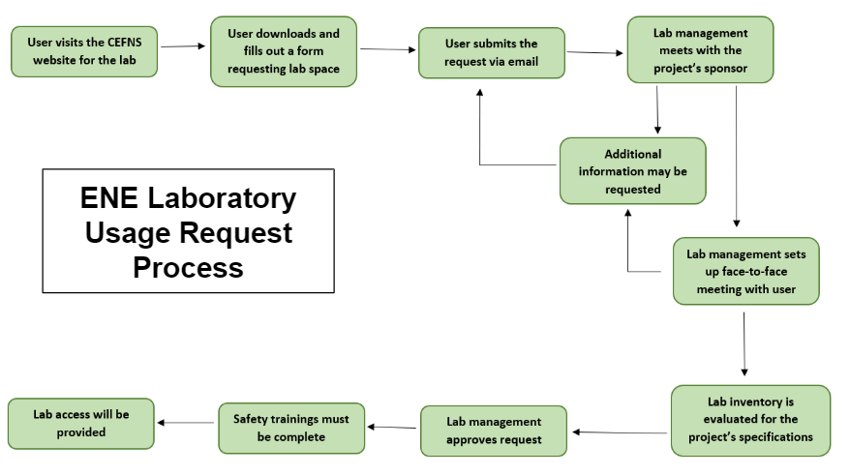

*ENE Laboratory Usage Request Process*

1. Parties who would like to request usage of the ENE lab visits the lab website hosted by the College of Engineering, Forestry, and Natural Sciences, and download the request form—a document the party will fill out with the relevant information
2. The completed form is then emailed to the lab management
3. Lab management reviews the request
   1. They meet with the project sponsor, which for students may be a faculty supervisor, course instructor, etc.
   2. This process may go back and forth repeatedly until lab management has determined they have all the information they need
4. Lab management arranges a face-to-face meeting with the requesting party
   1. This meeting may result in the requesting party having to submit more information
5. Availability of chemical inventory and project materials will be evaluated to determine the feasibility of the project
6. Lab management may approve or deny the request for lab usage, or they may require the party develop their project more before usage may be granted
7. All lab safety trainings must be completed
8. Lab usage may be granted

Alongside this paper- and email-based request system, there are two systems associated with the ENE lab: A.C.I.D., the chemical inventory, and BioRaft, the Environmental Health and Safety trainings database.

The online automated chemical inventory database (A.C.I.D.) is the chemical inventory system used by the ENE labs to track the different chemicals used in the labs. Users can look up which chemicals are available in the lab and some of the health and safety information associated with those materials, and lab management can update the system according to the lab space. This software was created and is maintained by NAU’s Information Technology Services (ITS) department, and is primarily used by the Environmental Health and Safety staff to ensure proper and legal use of chemicals in the university facilities. It has been expressed to us that the A.C.I.D. system may be improved upon, but this is not the primary goal of the project.

BioRAFT is a third-party software that facilitates and tracks the health and safety trainings of NAU personnel. This system is used to ensure that everyone in the lab has completed the required trainings to help avoid chemical interactions, health and safety violations, and overall poor behavior in the lab space.

**III. Solution Vision**

To solve our client’s problem, we propose a web application which will facilitate easy management of lab spaces and simplify the existing request process for both requesting parties and lab administration.

This is largely composed of two major components, the web interface and the database system which serve as the “front-end” and “back-end” respectively. The web interface itself, what the user sees, will allow for account registration, submission of lab use requests, and a way to view the status of said requests and the chemical inventory. The latter element forms the “back-end”—our web application will be run off of a robust database system that stores lab chemical and safety information, requests, and other necessary information as needed. Our application will consist of the following:

* A web application to streamline and automate the various aspects of the ENE lab
* Front-end: web interface
  + Register for user account
  + Submit requests for use of lab space
    - Check on said requests and see added information from faculty
  + Look at chemical inventories with proper safety and informational sheets as needed
  + Roles for administrators to add to inventories, approve requests, correspondence, and so forth
* Back-end: robust database system
  + Chemical inventory
  + Inventory of requests
  + Integration with A.C.I.D. (pre-existing, ITS-developed inventory system for campus labs)
  + Integration with BioRaft (safety and training module)

The data that this web application uses will be provided from an administrative source; those with an aforementioned admin role will be able to feed chemical data for inventory purposes to the application, and handle the requests sent by standard users, which are the two major points of the application itself.

The system will automate the existing processes, therefore reducing the overhead efforts in coordinating lab space and increasing lab productivity overall, and will streamline lab management into one easy location. Our intent is that the sponsor will find themselves with a much better system to handle this complex, multi-faceted process that is lacking in its current state.

We know that there may be aspects lacking in the way of boundless features (as in a desktop/software application) or immediate availability (in the case of a mobile application, for example), but the use of a web application is what we consider a proper middle ground for achieving each of the requirements set out and planned between the team and the client. The client has mentioned the potential for use of this system beyond NAU, and expressed the desire to commercialize it to support the lab’s further operation. It is our belief that our solution will be ideal in facilitating these possibilities.

**IV. Project Requirements**

The requirements for this project have been determined through discussion and collaboration with our clients and the team associated with the project over the course of this semester so we can ensure we develop a solution that fulfills their needs and solves the problem outlined earlier in this document. We have also used documents that outline the current process and policies in our analysis and requirements acquisition to ensure they are accurately implemented in our system.

In this section, we outline a sensible and comprehensive set of requirements we have created based on the past semester’s work on this project. The purpose of these requirements are to guide the project’s development for the rest of the capstone, and to serve as the rubric by which the project will be evaluated by ourselves throughout development, and by our client as the measure by which we have satisfied their needs.

Through these requirements, we have detailed a robust web application that facilitates lab usage requests and inventory management, in cooperation with the existing systems, that is built in mind for future ITS support and the potential for expansion should the client choose. There are two aspects of the project requirements: Domain requirements, and system requirements. Furthermore, the system requirements consist of three types: Functional, non-functional, and environmental. We will outline all of these in this section.

**A. Domain Requirements**

Domain requirements are the overall user requirements, which guides how this system will operate at the domain level and lay out the features the user needs. There are the requirements that explain what the user wants to do with the system in order to satisfy their needs, and the criteria by which our system’s performance at the user level is evaluated.

|  |  |
| --- | --- |
| **#** | **Requirement** |
| DR 1 | The system will be simple to use |
| DR 2 | The system will be easy to extend |
| DR 3 | The system will be accessible |
| DR 4 | The system will simplify the existing lab usage request process |
| DR 5 | The system will simplify lab management for administration |
| DR 6 | The system will enable the Standard Operating Procedure of the ENE lab |
| DR 7 | Administrators and users can register accounts |
| DR 8 | Users can manage their accounts, edit their settings, make requests for lab usage, manage their requests, view the chemical inventory, request new inventory or report a problem, and contact lab administrators |
| DR 9 | Administrators will be able to manage user requests, manage the lab space in the system, and contact users. |

These requirements will be carried out by the client-side operations in the system. Developing this system with the requirements that it is easy to use and extend, with high usability, will ensure the system will be able to optimally serve the lab in the long run. Usability is part of a broader term “user experience,” and describes the ease of access and/or use of the system, as determined by its features. A system with low usability may ultimately frustrate both users and lab administration, and lead to a system that is actually *less* usable than the current one.

As such, we will ensure a simple system that is easy to use, such that:

* It is easy for the user to start using the system, and easy for the user to become familiar with it quickly
* It is easy for the user to achieve their goal, whether that is managing the lab space or requesting use of the lab, using the system
* It is easy for the user to come back to the system and start using it again

With this in mind, we will maximize responsive design in develop, in order to fully realize an easy to use, simple system with high usability. We will also develop the system to be highly accessible so we can maximize the system’s usability and make it accessible to all users. We may use the Web Content Accessibility Guidelines (WCAG), along with other resources, to ensure an accessible system by maximizing perceptibility, operability, understandability, and robustness. This may include:

* Making functionality accessible by keyboard and other assistive technologies
* Designing with color blindness and visual impairment-friendly palette
* Designing a highly readable application
* Providing alternatives for content and media
* Using transcriptions of audio where necessary
* Providing methods for navigation
* Maximizing compatibility with current and future assistive technologies
* Making the web app appear and operate predictably
* Providing support for correction and avoidance of user mistakes
* Ensuring that, should an element not be accessible, the rest of the relevant content is

Much of our work to fulfill these domain requirements will involve providing ITS, future capstone groups, and anyone else who will be supporting the system a solid framework to continue building on, which will not compromise accessibility and usability.

It is also necessary that we develop the system within the requirements that it simplify both lab usage requests and lab management, given that these are the problems this system will exist to solve. These domain requirements will be fulfilled and explained more in-depth in the System Requirements section.

This system must also follow and facilitate the Standard Operating Procedure for the ENE lab, which are the guidelines by which the lab operates within the Civil and Environmental Engineering program. They detail the process for requesting lab space, and the policies and procedure for lab access and usage, and as such, define the domain in which our system will operate.

**B. System requirements**

In order to run smoothly and operate efficiently, the system must fulfill system requirements as well as user requirements. These system requirements define the capabilities of the system and how it functions to fulfill the user requirements detailed in the previous section, and they fall into three categories: Functional, non-functional, and environmental.

Each of these sections contribute to the design and development of a cohesive system that satisfies our client’s needs and ensures safe and efficient operation of the ENE lab.

**1. Functional Requirements**

Functional requirements define the system capabilities and functionality. They describe a behavior or function the system must be able to perform—specifically, function requirements determine *what* the system should do. These requirements do not define *how* these functions are to be implemented, merely detailing the criteria by which the system’s behavior will be evaluated.

We have detailed requirements for the system as a whole, as well as specifically for the different user types.

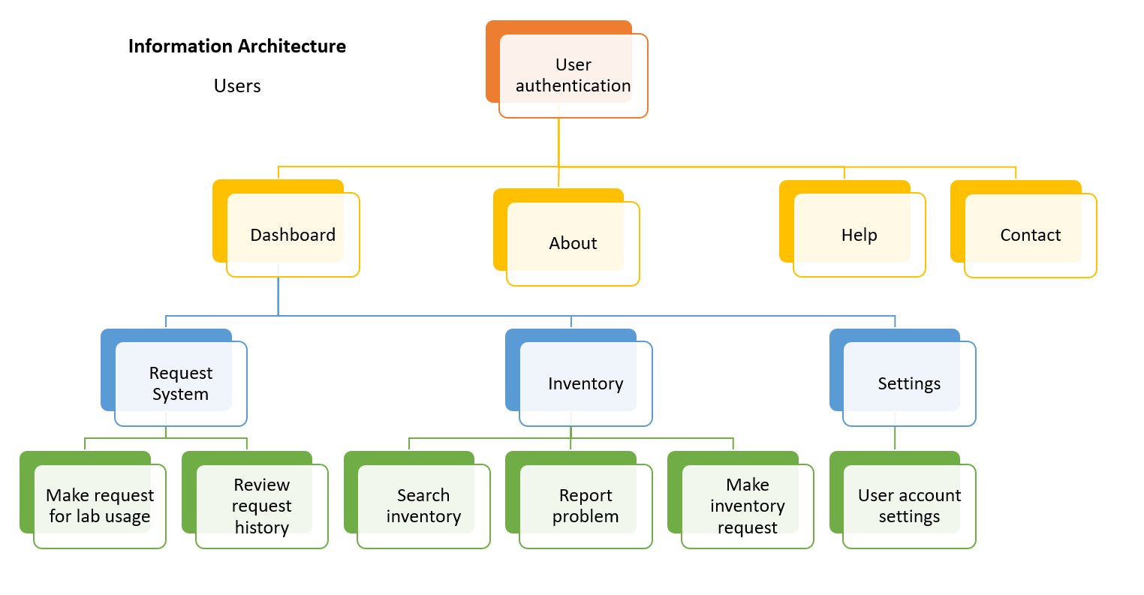

*A detailed tree of the user’s information architecture in the system*

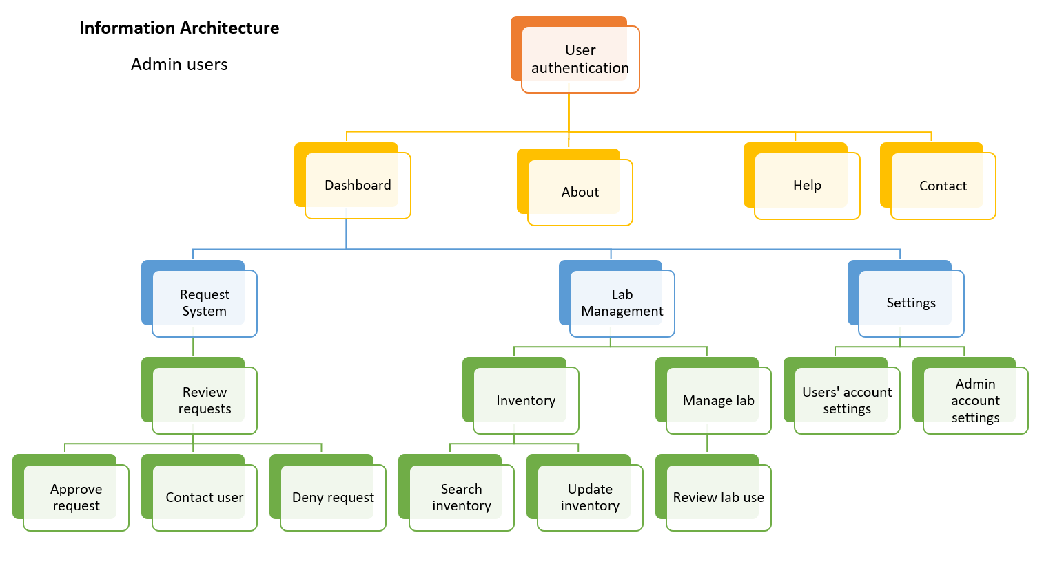

*A detailed tree of the administrative user’s information architecture in the system*

|  |  |
| --- | --- |
| **#** | **Requirement** |
| FR 1 | The system will process user authentication |
| FR 2 | The system will store and retrieve data with a database backend |
| FR 3 | The system will integrate with the existing BioRAFT system for health and safety trainings |
| FR 4 | The system will integrate with the existing A.C.I.D. system for inventory interaction |
| FR 5 | The system will support two types of users: Standard and Admin |
| FR 6 | All users can create accounts |
| FR 7 | All users can manage their account |
| FR 8 | All users can request new inventory |
| FR 9 | Standard users can submit requests for lab usage |
| FR 10 | Standard users can manage their existing requests |
| FR 11 | Standard users can view their request history |
| FR 12 | Standard users can search the lab chemical inventory |
| FR 13 | Standard users can contact administrative users |
| FR 14 | Standard users can report problems with the chemical inventory |
| FR 15 | Standard users can schedule face-to-face meetings with admin users |
| FR 16 | Admin users can manage standard user accounts |
| FR 17 | Admin users can manage the lab inventory |
| FR 18 | Admin users can contact standard users |
| FR 19 | Admin users can schedule face-to-face meetings with standard users |
| FR 20 | Admin users can manage how the lab space is represented in the system |
| FR 21 | Admin users will be able to access and manage the database backends of the system |
| FR 22 | The system will utilize a web form to receive and process the lab usage requests from standard users |
| FR 23 | Admin users can approve or deny lab requests |

We detail the functional requirements defined above here. These functional requirements will be carried out by client-side operations for the user, and powered by server-side operations in the software and database.

The system will process user authentication of registered NAU users requesting usage of the ENE lab, and allow them to register accounts with the system. User registration is necessary to use the system, and will facilitate account management, such as adjusting settings and changing details. All users will be able to do this, whether they are standard users or administrative. User information will be stored securely in a database backend, which will support two types of users: Standard and Admin. This allows the system to operate in different modes for the different users. It also allows administrative users to edit user information.

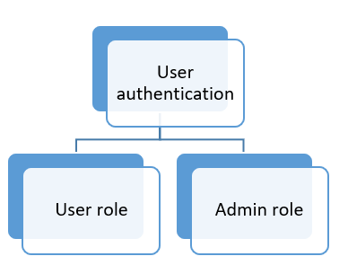

*The system will have two roles: User and Admin*

The database will also store lab usage request information submitted by users, and will facilitate lab administors to manage how the lab is treated by the system. Administrative users will be able to access and manage the database backends of the system, which will facilitate many of the other functional requirements associated with administrative users. This will include managing lab usage requests, user accounts, and how the lab space is represented in the system, which may include editing lab availability and indicating which spaces are off-limits. This will also help standard users in creating their lab usage requests, as it will help give an up-to-date and accurate idea of what the lab looks like at any moment.

The system will utilize a web form in order to receive lab requests from users, facilitating the process by providing all of the fields, indicating which fields are required, and sending the form to lab management. Users will be able to submit requests for lab usage using the form, which sends the information to the system’s database; the system authenticates and validates this request, and sends on the request to the lab administration for review. Users will also be able to view their request history, including open and closed requests, and edit open ones for resubmission.



*The process for a lab usage request submission from user to lab administration*

Administrative users can approve or deny lab requests submitted by standard users, which indicates whether the requesting party can utilize the ENE lab space for their project or not.

The system must integrate with the existing BioRAFT system NAU uses to manage health and safety trainings in order to ensure a safe and legal lab environment, and it must integrate with the existing A.C.I.D. system for inventory interaction, which will allow the system to fulfill other functional requirements. These requirements are crucial for administrators’ to fully process lab usage requests, and manage the lab spaces. This also facilitates users being able to search the A.C.I.D. system for the lab inventory, such as checking to see if a specific chemical is in stock in the correct amount, and will let lab administration monitor the inventory. Users will also be able to request new inventory to be added to the A.C.I.D. system, which can only be done by lab management.

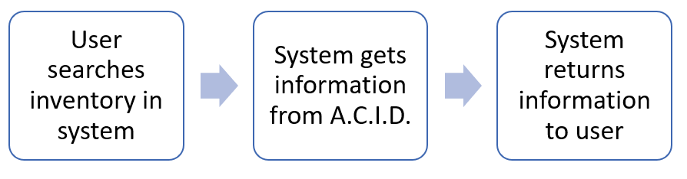

*The process for the system’s integration with the A.C.I.D. program*

Lab management will be able to manage the lab inventory, which may include adding or deleting inventory from the A.C.I.D. system, or editing the information associated with an entry.

Users will also be able to report problems with the inventory, such as A.C.I.D. reporting the presence of chemicals not physically in the lab. Lab management will be responsible for updating the system, as they are now, but it will give users greater power in the process, create a record of problems with the inventory from the users’ point of view, and make it easier for lab management to know what needs to be fixed.

Standard users will be able to contact lab administration, and vice versa, lab administration needs to be able to contact standard users. As part of the lab usage request process, it’s necessary for users to meet with lab management in a face-to-face meeting, and the system will help facilitate this. An actual scheduling system would be the work of a future update, not initial development, but we’d like to set the stage for the possibility.

**2. Performance (non-functional) Requirements**

Non-functional requirements, also called ‘performance requirements,’ define the system’s performance. They describe how the system should behave, and how the system works. Because this web application will be dynamic, constantly changing, and always responding to the needs of lab users and administrators of the system, we have a few essential pre-defined requirements of this regard that we aim to achieve. In these requirements, we need to set out the criteria by which our system may be evaluated for the actual operations it performs rather than its specific behaviors.

|  |  |
| --- | --- |
| **#** | **Requirement** |
| PR 1 | The app should load quickly |
| PR 2 | The app should always work reliably |
| PR 3 | The app should respond comfortably to user input |
| PR 4 | The app should be easy to maintain |
| PR 5 | The app should support data integrity |

* **App should load quickly**. It should be fast and reliable to create a more pleasant user experience overall
* **App should always work reliably**. This is a critical requirement, as the inventory and request systems should always be open and functional for safety and efficiency purposes
* **App should respond comfortably to user input**. The application should be intuitive to students and faculty with all levels of technological experience
* **App should be easy to maintain**. ITS plans to support this system in future semesters after the academic year is over
* **App should support data integrity**. The data we receive from already existing sources like A.C.I.D. and BioRAFT should be handled and processed in an accurate fashion

In addition, keeping these requirements in mind, we intend for our application to excel in five major ways as extensions of the original five non-functional requirements.

|  |  |
| --- | --- |
| **#** | **Requirement** |
| PR 6 | Speed |
| PR 7 | Usability |
| PR 8 | Extensibility |
| PR 9 | Scalability |
| PR 10 | Accessibility |

* **Speed**: The lab tool needs to work quickly and rapidly respond to input given by the user. Accessing chemical data, request data, and so forth in a timely manner, especially in lab, is a crucial aspect to making sure our application meets client requirements satisfactorily. We will utilize appropriate tools during development and testing to measure and evaluate the application’s bandwidth usage and speed, with a focus on the server’s capabilities.
* **Usability**: The system has to have a wide range of features while also being able to accommodate the needs of users with any experience level of technology use. This is largely how we will ensure our domain requirements are implemented correctly.
* **Extensibility**: The system is required to be built in mind with future ITS support. We need to make sure that we are building a system that can be extended and developed further upon completion of our capstone sequence. This will be expanded on in our Environmental Requirements.
* **Scalability**: Our application has to account for the fact that the system could grow far beyond both our expectations and what we anticipate. The inventory system, for example, could grow increasingly large and become more complex, and we need to account for this at the base level when building our first prototypes.
* **Accessibility**: In a similar manner to usability as mentioned above, we simply need to ensure that the application can be accessed by all required parties (students, faculty, administrators, ITS, and so forth) in a manner that is intuitive, straightforward, and clear from all perspectives and roles.

**3. Environmental Requirements**

Environmental requirements define the context the system exists in. At NAU, there is an extensive software ecosystem in which this system must operate, and we must take that, which is a requirement in and of itself, into account when creating our system. Following our completion of our capstone and our system is deployed, it will be managed and supported by NAU’s ITS department. NAU ITS operates and supports software that consists largely of Microsoft technology, and is moving farther away from other technologies in order to foster a united software ecosystem. Our system must be easily integrated *into* this ecosystem in order to be functional at NAU and facilitate any further development which may occur after our project has completed, and will be hosted by ITS on their servers.

This knowledge provides us with several environmental requirements that will need to be factored into the development of the system.

|  |  |
| --- | --- |
| **#** | **Requirement** |
| ER 1 | The system must be compatible with the existing NAU software ecosystem |
| ER 2 | The system must be supportable by NAU ITS |
| ER 3 | The system must have cross-browser compatibility |
| ER 4 | The system must be able to meet our other requirements on multiple platforms |
| ER 5 | The system must follow and enable the Standard Operating Procedure for the ENE lab |

Compatibility with the NAU software ecosystem introduces some constraints on our development, such as the necessity we implement this system using tools and languages approved by ITS. We hope to ensure this by working closely with ITS throughout development, so that we can catch and mitigate problems before they interfere with system functionality and effectiveness.

The system needs to be compatible across browsers, so that it doesn’t matter if a user is using Safari, Chrome, or another browser to access the system, or if the system is being used on a desktop, tablet, or mobile phone. We will need to ensure graceful degradation of the system across platforms, meaning it will adapt to smaller sized screens or less capable browsers. Part of this will be designing the system’s front-end so that it adapts to different views, and another part will be ensuring the back-end can handle the difference in platforms.

This system must also follow and enable the Standard Operating Procedure for the ENE lab, which dictate the lab usage request process, as well as the policies and procedures of lab operation. This is an environmental, as well as domain-level, requirement for the system.

Should we fail to keep these requirements in mind, we risk creating a system that is unsupportable and unusable, and we fail to solve our client’s problem. We will go further into this as a risk in the next section.

**V. Potential Risks**

There is inherently always a set of risks with large scale software projects such as these, and we have taken time to evaluate the issues that may become the most apparent as we work through our solution.

During the synthesis of our solution, we evaluated several risks associated with finding the ideal solution. We considered three different possible solutions: A mobile application, desktop software, and a web-based application. Each of these came with their own individual benefits, but also risks we needed to consider before settling on out solution.

|  |  |
| --- | --- |
| **Mobile app** | **Pros:** Portable, fast, continuous availability, easy for users to make requests  **Cons:** Not ideal for managing the different aspects of the lab, too many features could make the app too big, cross-platform compatibility |
| **Desktop software** | **Pros:** Makes it easy to have a lot of features, easy to have different modes for normal users and lab administration  **Cons:** Difficulties with cross-platform compatibility, difficult maintainability requiring software updates, would have to be installed on every device, limited availability only on desktops and laptops as opposed to mobile devices |
| **Web app** | **Pros:** Portable, platform independent, available on any device with a browser, easy to facilitate modes for normal users and lab administration, accessibility, zero installation for users, easily maintainable  **Cons:** Cross-browser compatibility, requires an Internet connection |

Ultimately, we chose to implement our solution as a web-based application. This carries its own set of risks, including web security and an inability to correctly implement cross-browser compatibility. We believe we can mitigate these risks if we take appropriate measures during development. There are still some risks that we face when we go into development.

* Integration issues
  + A.C.I.D., BioRaft, ITS tools
* Registration problems
* Request form problems
* Non-working inventory
* Issues with learning ITS-sponsored tools we are required to use for the project
* Hazards and safety risks that could arise from any incorrect configurations above

Not all of these issues are as critical as others. We will ultimately determine through trial and error and working through the project which issues are the most apparent to us, but right now, it seems that the biggest points of contention will be the aforementioned integration issues and avoiding problems we may run into regarding the ITS toolset. There are potential problems involved with trying to integrate our system into the existing NAU software ecosystem, which we will address as they come up.

If we fail to correctly integrate these systems, or our system cannot fit into the NAU software ecosystem, then our system may not be able to be deployed and we will fail to create a system that appropriately addresses our client’s problems. Furthermore, if the system doesn’t work with A.C.I.D. or BioRAFT, then we will also fail to fully meet our requirements. This failure to meet our requirements is also an issue if we should have problems registering users, or if the request form does not correctly work.

**VI. Project Plan**

The project and software development will progress along the timeline set by NAU’s CS capstone program across two semesters, as well as a timeline we have created. As we feel it is unrealistic to set specific dates, our project plan is based on a series of project milestones with rough timelines to give us some flexibility, which we outline here in a Gantt chart.

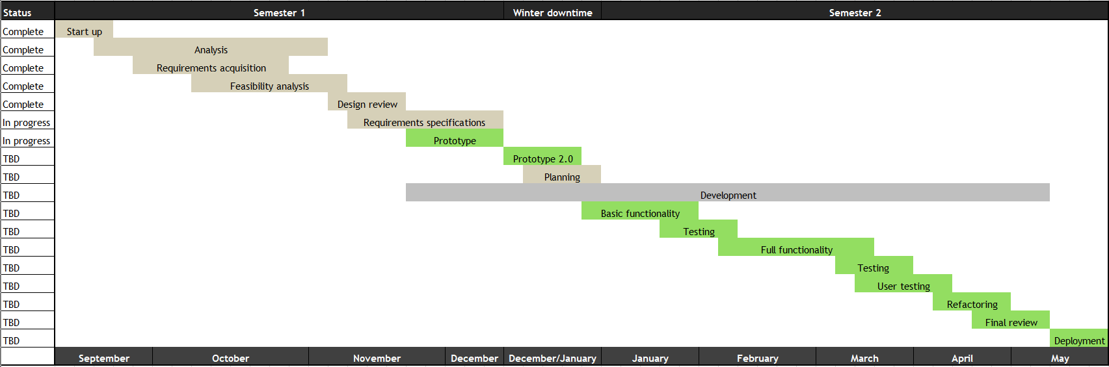

*Planned progression of the project*

We explain each of these milestones below, detailing what they mean for the project and its progression.

* **Project start-up**: Project assignments and team website development
* **Analysis**: We began meeting with our clients and determining what the client’s needs are
  + **Requirements acquisition:** Determining what problem the project will solve, how it will solve those problems, and what kind of technologies we may employ to do so
* **Feasibility analysis**: Analysis of how we can solve these problems and create this software realistically using technologies, what challenges we may face, and how we’ll solve them, and ultimately, what technologies we will use to create this system
* **Design review:** A review of the project and how we intend to create it
* **Requirements specifications:** A determination of what requirements this project will have, and how we intend to address them, culminating in this document which will serve as our guide going forward in this project
* **Prototype:** The initial prototype for a tech demo, which serves as a proof of concept, and demonstrates the practical feasibility of the software. We intend the prototype to be the request system, as a demonstration that this project is feasible, that we will continue to build on throughout the project
* **Prototype 2.0:** A redo of the prototype, ironing out any issues, so that we may progress with further development (may possibly be combined with the original prototype if we find it unnecessary)
* **Planning:** We will complete planning for the full development and implementation of the software, so we have a blueprint to use for the semester
* **Basic functionality:** An implementation of the framework of the system and the bare essentials so the system exists at its lowest level, which we can flesh out in the next stage for a complete
* **Full functionality:** We fully flesh out the system so that it fulfills all requirements and is ready for final user testing and eventual deployment
* **User testing:** The system will be evaluated both by the client and by regular users, such as students, who will be using it
* **Refactoring:** We will make any changes necessary before deployment (this will overlap with the client’s final review)
* **Final review by client:** The client will do their final evaluation of the system in conjunction with our final refactoring
* **Deployment of software:** The system will go live at the end of the semester, at the client’s discretion

We are pursuing a test-driven development process, and as such, testing will occur throughout the development process, so it doesn’t have its own milestones in this project plan.

We will perform testing with different types of users, including the client and lab management, as well as targeted user testing with students in the Environmental Engineering program who would use this system in practical application to request usage of the ENE lab for their own research projects and classes; it’s important that the users of our system evaluate it before its deployment, so we don’t release a product that’s actually difficult, or even impossible, for real use.

**VII. Conclusion**

Our project will address the current difficulties and inefficiencies of the Environmental Engineering (ENE) lab management and usage processes, as explained to us by our client, Dr. Terry Baxter. The ENE lab supports research into, among other topics, climate change, water safety, and sustainability, which contribute to global efforts of preserving the environment. When there are failures or issues with research or data, which can occur in any number of ways, that endangers the validity of the results, and as a whole, endangers the field of environmental engineering. Consequently, this may affect life on Earth as a whole. The ENE lab critically needs a system that centralizes the management and lab usage processes in order to operate efficiently.

We propose a robust web-based application that will combine lab usage requests and lab management into one system, allowing users to make requests for lab usage and check the lab’s inventory, as well as facilitating lab management’s maintenance of the space, all in one convenient place. This app will be portable, platform independent, and easy to maintain, and will ensure the safe and efficient operation of the ENE lab.

In our efforts to solve this problem and make our solution a reality, we have completed our analysis of the requirements and feasibility of different technologies, and determined what requirements we must fulfill to fully implement this system. We are currently developing a prototype of the request form aspect of the system for our tech demo as a proof of concept, and we are confident that we will be able to fully implement a web-based system that addresses and solves our client’s problems by the end of this capstone project.

**VIII. Glossary**

|  |  |
| --- | --- |
| **Term** | **Definition** |
| **A.C.I.D.** | The online *a*utomated *c*hemical *i*nventory *d*atabase is the chemical inventory database system used in the Environmental Engineering laboratories for chemical information, health and safety information, and inventory management |
| **Accessibility** | The design of a system to be used by anyone, including persons with disabilities, such as the ability to use a screen reader or speech-to-text software with a system |
| **Back end** | The portion of the system that runs and operates the front end, and is not directly accessed by the user, such as any programs and databases; the functioning parts of the system that do all the work |
| **BioRAFT** | The third party software used by NAU’s Environmental Health and Safety department to track the necessary health and safety trainings required and completed by personnel for the labs at NAU |
| **Client side** | Operations that are performed by the client in a client-server relationship; operations performed by a computer application such as a web browser giving the user access to the web app |
| **DBMS** | The *d*ata*b*ase *m*anagement *s*ystem is the software used to manage and interact with a database |
| **Domain requirement** | How the system will satisfy the user’s needs at the user level; also called ‘user requirements’ |
| **ENE** | Environmental Engineering, used in reference to the academic program and the laboratory operated by the program |
| **Environmental requirement** | A requirement for the context the system exists and operates in |
| **Extensibility** | A measure of the ability to extend or grow the system in the future, such as adding new functionality or modifying current functionality. Extensibility often overlaps with scalability |
| **Front end** | The portion of a system directly accessed by the user, such as the website or a menu; the layout, visuals, and human-computer interaction of a system |
| **Functional requirement** | A function the system must be able to perform; what the system should do |
| **Non-functional requirement** | A behavior the system must be able to perform; how the system performs; also called ‘performance requirements’ |
| **Performance requirement** | Please see ‘Non-Functional Requirement’ |
| **Prototype** | An early model of a product built to test a concept or process, or as proof that a system is possible |
| **Scalability** | A system’s capability to handle a growing amount of work. Scalability often overlaps with extensibility |
| **Server side** | Operations performed by the server in a client-server relationship; operations performed by the web server running the web app and database |
| **Software ecosystem** | A collection of software projects which are created and operate in the same environment |
| **SOP** | The rules and guidelines for the operation of the Environmental Engineering laboratories, which detail the policies and processes for operating the lab, as well as the process for requesting lab usage |
| **Usability** | Describes how easy a system is to use and how easy or intuitive it is to learn; the extent to which a system can be used by specified users to achieve specific goals |
| **User requirement** | Please see ‘Domain Requirement’ |
| **W3C** | The World Wide Web Consortium; the main international standards organization for the World Wide Web |
| **WAI-ARIA** | ‘Web Accessibility Initiative -- Accessible Rich Internet Applications’; a technical specification published by the W3C that specifies how to increase the accessibility of web pages; consists of a suite of several documents detailing specifications, problems, and best practices for developing highly accessible web applications |
| **WCAG** | The ‘Web Content Accessibility Guidelines’ are a W3C checklist to evaluate a website or application’s accessibility to disabled users |
| **Web application** | A program that runs in and can be used through a web browser |

**IX. Appendices**

1. Standards Operating Procedure
2. Lab Usage Request Form



Standard Operating Procedure

AMBL-001-A

Prepared:

/21/2017

6

Revised:

/16/2018

11

Prepared by:

Terry E. Baxter

Reviewed by:

Requesting Use of the Environmental Engineering Laboratory and Laboratory Services

# SOP SUMMARY

This SOP describes the procedure for requesting the use of space and services from the environmental engineering laboratory and the policies and procedure for laboratory access.

# ENVIRONMENTAL HEALTH AND SAFETY

Hazards Assessment: This procedure does not contain hazards.

Safety Equipment and Engineering Controls: This procedure does not require the use of safety equipment or engineering controls.

Personal Protective Equipment (PPE): This procedure does not require the use of PPE.

Analysis-derived Wastes and Disposal:

|  |  |  |  |
| --- | --- | --- | --- |
| Waste Generated | Hazardous  ( Y / N) |  | Disposal |
| This procedure does not generate wastes. | N | None |  |

PROCEDURE DESCRIPTION

# 1.0 Introduction and Applicability

The Environmental Engineering Laboratory consists of 3 adjoining laboratory rooms that support instructional, project and research activities. In addition to requesting the use of physical space, equipment and supplies maintained within these facilities, laboratory services may also be requested.

Laboratory spaces and services are available first and foremost to support the faculty and students of the Civil Engineering, Construction Management and Environmental Engineering Department, and students working in collaboration with either the department’s faculty or students. Non-departmental faculty and students may request the use of the Environmental Engineering Laboratories and its services on a fee basis.

Laboratory space, its equipment and supplies, and the services that can be provided are not limitless. As the number of users increase, the ability to approve requests and schedule the use of space and equipment becomes more difficult. Submitting a request does not guarantee that your request can be approved. Planning as far in advance as possible is highly recommended.

This procedures and polices described herein are considered applicable to all individuals and organizations requesting use of the Environmental Engineering Laboratories or its services.

# 2.0 Definitions for Terms and Abbreviations Used

1. AMBL. Applied Microbiology and Biotechnology Laboratory
2. Authorized User or User. An Authorized user is any individual authorized to use the laboratory space, equipment or services, either by having initiated a request as an individual or under a group or organization. A group or organization requesting use must identify all individual users. While students defined in Section 4.2.c are authorized users, their access outside of class time is limited. Authorization to use the laboratory is only assigned to individuals after they have satisfactorily fulfilled requirements of the laboratory use request and all institutional and local safety training requirements.
3. Building Manager. The staff member designated to manager all aspects related to the operation and maintenance of the Engineering Building.
4. Institution/institutional. Northern Arizona University is the institution and institutional refers to Northern Arizona University’s policies, procedures, systems and individuals having an official standing with the institution of Northern Arizona University.
5. Laboratory. Laboratory refers to the Environmental Engineering Laboratory including its equipment and supplies.
6. Laboratory Access. Laboratory access refers to entering the laboratory space. Authorized laboratory access is only granted to an authorized user or individuals having a predetermined need for access. Unauthorized access occurs when an individual enters the laboratory without access authorization and is considered a violation of the Sitespecific Chemical Hygiene Plan for the Environmental Engineering Laboratory, referred to as the Laboratory Safety Standard.
7. Laboratory Director. The Laboratory Director is a faculty member having oversight of the overall operation and administration of the laboratory. In the absence of a faculty member serving in this role, the department Chair becomes the Laboratory Director.
8. Laboratory Manager. The Laboratory Manager is a faculty or staff member responsible for the day-to-day operation of the laboratory. In the absence of a Laboratory Manager, the Laboratory Director fulfills these responsibilities to the extent possible.
9. Primary Contact. A principal investigator or individual user otherwise identified as the person through whom the Laboratory Manager or Laboratory Director directs communications concerning the use of the laboratory, and the work being conducted in the laboratory or the services being provided by the laboratory.
10. SOP or Standard Operating Procedure. An SOP provides specific instructions regarding a policy, process, or procedure that are applicable to this laboratory. The intent of an SOP is to provide information that ensures all individuals performing a procedure, following a process, or adhering to a policy will be able to do so in the same way. In addition to providing step-by-step procedural instructions, many SOPs contain environmental health and safety information that extends this laboratory’s site-specific chemical hygiene plan and local safety training program.
11. Supervising Faculty. A supervising faculty is a department faculty member who is a principal investigator or supervisor of students performing work in the laboratory. This includes faculty teaching courses that are regularly scheduled in the laboratory and faculty teaching course not regularly scheduled in the laboratory but having students who are authorized users under a laboratory request directly related to a required or optional course activity.
12. Visitor(s). An individual or group of individuals accompanied by the Department Chair, Laboratory Director, Laboratory Manager, a supervising faculty member, or a professional employee of NAU carrying out the regular duties of their job. Generally, any person not otherwise considered an authorized user is a visitor and must be accompanied as described in 4.1b.

# 3.0 Request Procedure and Policies

1. Obtain a copy of the EnE Laboratory Services Request Form. This form may be downloaded from the following location: http://www.cefns.nau.edu/~teb/ambl/sop/CECMEE_LabUseRequestForm_Rapid.docx
2. Complete and submit the request form to the laboratory no less than 2 weeks prior to when you intend to start work.
   1. Project or Course name. Enter the name of the project to which the work is related or when the work is part of a class not otherwise scheduled to use the environmental engineering laboratory, enter the class name. As an example, a capstone project could be simply, CENE Capstone LID Team.
   2. Faculty Supervisor or Course Instructor. This is the faculty member who the most knowledge of your work and is considered responsible for overseeing your work. If the work is part of a class not otherwise scheduled to use the environmental engineering laboratory, then enter the teacher’s name.
   3. Source of Funds/account number used for this project or course. When available; otherwise enter an account number; otherwise simply describe the funding source. For example, a capstone project or other project related to a class not otherwise scheduled to use the environmental engineering laboratory may simply enter, Class Fees.
   4. Start Date and End Date. Enter, to the best of your ability the planned starting and ending dates for the work to be done.
   5. Objective of Laboratory Work. This should provide a brief description that is able to communicate the type of work that will be done and what the result of that work is expected to be.
   6. Primary Contact/Course TA (Name) and NAU User Name. This is generally the name of the person completing this form, but in all cases for projects this should be the person both doing the work and the most knowledgeable about the work. If this is work that a course TA is doing or will be supervising, then the name of the course TA would be entered as the primary contact.
   7. Projects only: List all individuals who will participate on this project.

List anyone who is going to conduct work in the environmental

engineering laboratory under this project so that each person’s safety training status can be verified.

1. The Laboratory Manager or Laboratory Director will contact faculty sponsor or course instructor, and the project’s primary contact or course TA, to discuss the request and determine what additional information is needed and whether there is adequate laboratory space and resources to support the activity.
2. Note that you will be required to provide a planning document (e.g., a project plan, study plan, work plan, sampling and analysis plan, experimental plan, etc.) that provides more detail about the proposed activity planned. At a minimum, the planning document should provide the following information.
3. Project title.
4. Names and contact information for all individuals performing project work and whether they will be entering the laboratory space.
5. Project background and project objectives.
6. Project approach for each objective.
7. Planned laboratory and/or field activities, the duration (starting and ending dates) of each activity, and the person(s) responsible for performing each activity. Your end date should include time for clean-up activities after the project has completed.
8. Types of samples (matrix) to be collected or otherwise received, handled, or stored, and sample storage requirements.
9. Identify the parameters that you will be determining (for each sample matrix) and the methods of analysis or measurement that will be used or developed.
10. Identify all hazards associated with each of your sample types, and methods performed.
11. Identify all non-hazardous and hazardous wastes that your activities will generate and their waste disposal requirements.
12. Identify all laboratory and/or field equipment, laboratory supplies and chemicals that will be used.
13. Identify all safety protocols that are associated with conducting work in the lab and field.
14. Identify all training that has been completed and training that will be completed in order to perform the work correctly and safely.

An academic course or training workshop may use the course syllabus or workshop agenda with a schedule and laboratory activity assignment sheets as their planning documentation.

A copy of each planning document will be kept in the laboratory so hazards associated with a project’s activities can be communicated to other laboratory users.

* 1. Once the request has been approved and all safety and project planning requirements have been completed, access to the laboratory will be provided.
  2. Projects that need to extend their originally planned activities should notify the Laboratory Manager or Laboratory Director as soon as possible so that necessary arrangements can be made should this change impact the scheduling of other projects.
  3. Reoccurring courses or workshops need only to submit request and planning documentation once, unless changes to the schedule or laboratory activities are being changed. In this case, only the changes need to be communicated to the Laboratory Manager or Laboratory Director so that the original request may be modified.
  4. A reoccurring course must submit an updated course roster during the week prior to the beginning of the semester and again after the roster has been finalized.

# 4.0 Laboratory Access Policy

The environmental engineering laboratory spaces not only present known chemical hazards because of the routine use and storage of chemicals throughout the laboratory, but can also present a variety of ever-changing chemical and/or biological hazards depending on the nature of the course, project or research activities being conducted. This makes it difficult for individual users to be fully aware at all times of the hazards that may exist.

In addition to security concerns, laboratories are designed to maintain a negative air pressure with regard to adjacent spaces so that air flows into the laboratory and that transport of chemical vapors may be minimized in the event of an accidental spillage. Proper balance of this airflow condition requires that the laboratory doors remain closed.

For these reasons, the doors to the laboratory are required to be closed and access to the laboratory space is controlled by the doors remaining locked at all times. At no time should the doors be propped open to allow others to enter without their NAU ID card or key.

Access to the laboratory is granted based on having official standing with Northern Arizona University and a legitimate or demonstrated need to use the laboratory, or to perform work in the laboratory that is associated with the legitimate duties for an official institutional function, or the need to enter the laboratory for emergency response.

# 4.1 Laboratory Access Granted by Official Institutional Function

1. Access is granted to all personnel who must enter to perform the regular duties of their job. This includes personnel with Engineering Programs, Environmental Health and Safety, Facility Services and the NAU Police Department.
2. Access is granted to visitors who are accompanied by the Department Chair, Laboratory Director, Laboratory Manager, a supervising faculty member, or an individual identified in 4.1a while carrying out the regular duties of their NAU job. The person accompanying the visitors becomes fully responsible for the behavior and safety of the visitors, and as such should at a minimum seek guidance from either the Laboratory Manager or Laboratory Director on laboratory-specific safety considerations.

4.2 Laboratory Access Granted by a Pre -established Legitimate Need a. Access is granted to the Department Chair, the Laboratory Manager, and the Laboratory Director.

1. Access is granted to faculty (and teaching assistants) who are teaching a course that is scheduled to meet in Room 245 for the duration of time needed to prepare, teach and clean-up after the course has completed.
2. Students enrolled in a course are granted neither card nor key access to the laboratory. Access for students enrolled in a class that is scheduled to meet in Room 245 is provided for the duration of the semester by the door to room 245 being unlocked from between fifteen minutes prior to the start of class until sixty minutes after the start of class. Each student’s access outside of this unlocked period of time must be controlled and supervised by the course instructor (or teaching assistant).
3. Access is granted to the instructors of a workshop scheduled to meet in Room 245 for the duration of time needed to prepare, teach and clean-up after the course has completed. Workshop participants are granted neither card nor key access to the laboratory, and their access must be controlled by the workshop instructors.

# 4.3 Access Granted by Request and Demonstrated Need

1. Access is granted to faculty who are conducting or supervising approved student projects for the duration of the activity described on the laboratory request form.
2. Access is granted to authorized users for the duration of the activity described on the laboratory request form.
3. Access is granted to faculty (and teaching assistants) who are teaching a course that is not scheduled to meet in Room 245 but who have requested use of the laboratory for the duration of the activities specified on the laboratory request form.
4. Students enrolled in a course scheduled to meet in Room 245 can individual access by submitting a separate EnE Laboratory Services Request Form. Card access may be granted for discreet periods of use but never for the duration of the semester.
5. Students enrolled in a course that is not scheduled to meet in Room 245 but will perform activities in the laboratory are granted neither card nor key access to the laboratory. Access must be controlled and supervised by the course instructor or teaching assistant defined in 4.3.c.

# 4.4 Access Conditions and Restrictions

1. Access is granted on the condition that the appropriate and necessary safety training for the work to be performed in the laboratory has been completed. The exceptions to this is for the access granted under 4.1.
2. Access to the laboratory can only be approved either individually or jointly by the Laboratory Manager and Laboratory Director. Their role in the laboratory is such that they are most familiar with the projects that are being conducted or being planned, as well as the laboratoryspecific safety issues associated with these projects.
3. Authorized users who are not listed in 4.1b or who are not a course instructor or course teaching assistant cannot allow anyone who is not a current authorized user to enter the lab.
4. Authorized users who are listed in 4.1b and 4.4.c can only allow an unauthorized user into the lab as a visitor and must accompany them at all times with the full responsibility for their safety and behavior as stated in 4.1b.
5. Access is not granted to chemical storage areas. All access to these areas must be coordinated with and supervised by the Laboratory Manager or Laboratory Director.
6. Access will generally be automatically revoked once the end of the activity requiring the use of the lab has concluded. This includes the ending of activity related to projects, scheduled courses and workshops, unless an extension is required to complete clean-up.
7. Access is revoked, regardless of need, when specified violations of this policy or the laboratory safety standard or safe laboratory practices occur. Safety violations that can trigger the revocation of laboratory access are described in the laboratory Safety Standard, and must be documented using an Incident Reporting Form.
8. A course instructor may request access revocation of any individual enrolled in their course (this implies that access has been granted to the individual), if there is reason to believe that the individual might create a potentially unsafe situation for themselves or others. This must be supported by an Incident Reporting Form documenting the safety violation leading to this conclusion. This request is made to the Laboratory Manager or the Laboratory Director who must consult with the Laboratory Manager.

# 4.5 Access and Working when a Class is in Session

1. A course regularly scheduled in room 245 is considered to be concurrently scheduled for room 242. These two rooms are joined and form the Instructional and Student Projects Laboratory.
2. It is the instructor’s prerogative to restrict access to these rooms during their regularly scheduled class time. Unless explicit permission has been granted by the instructor of the regularly scheduled course, individual users and visitors may neither access nor work in either room 245 or 242 while a course is in session. Neither the Laboratory Manager, Laboratory Director nor Supervising Faculty members can grant this permission.
3. All individual users should plan their work to be conducted at times that do not overlap with those times when a class session is being conducted.
4. Individual users having been granted explicit permission by a course instructor to work in room 245/242 during any part of the time a class is in session, must do so in a manner that does not interfere with the activities of the course.
   1. Permission to work during a regularly scheduled class session is a privilege that the instructor has granted and is not a right. The instructor may ask individual users not enrolled in the course to leave at any time.
   2. Users must not perform any procedure that unnecessarily interferes with the lecture or the lab activities conducted in the course. Although working quietly and avoiding using equipment that is being used by the class is generally adequate, it is up to the instructor to decide what constitutes an interference.
   3. Users must not perform procedures that could potentially create a hazard either to themselves or others – this includes conducting a routine procedure where being distracted by what is going on in the class could cause a chemical or liquid spill onto the laboratory bench or floor.
   4. Users working in the lab when a class is in session must also remain aware of potential hazards that may be created by students

in the class who may be performing a procedure for the first time. Depending on the nature of the potential hazard, reporting this to the instructor is generally sufficient.

1. Instructors who have granted an individual user permission to work in the laboratory during the time when their course is in session do not assume a supervisory role over this user nor do they become directly responsible for the safety of that user. However, in regard to being responsible for their own students’ safety, instructors must maintain an awareness of the work that an individual user is conducting so that potential hazards can be quickly identified.
   1. The instructor has full discretion to decide what constitutes a potential hazard to their students.
   2. Depending on the nature of the potential hazard, either discussing this with the individual user or asking the user to cease the activity creating the potential hazard is generally sufficient.

# 5.0 Requesting or Revoking Laboratory Access

1. Access to the laboratory must be requested through the Laboratory Manager, or Laboratory Directory when there is no Laboratory Manager.
2. The Laboratory Manager will work directly with each individual user requesting access to complete the process that provides access.
3. Revoking access to the laboratory is a change of access status that is initiated either by the Laboratory Manager or by a Supervising Faculty member or course instructor in consultation with the Laboratory Manager.
4. The Laboratory Manager or the Supervising Faculty Member or course instructor must inform the user, or users, about this change of access status. In most cases, access revocation must be accompanied and supported by an Incident Reporting Form.
5. The Laboratory Manager, or Laboratory Directory when there is no Laboratory Manager, processes this change of access status.

6.0 Laboratory Services

# 6.1 Standard Services

Certain services are provided to all users and are considered part of the laboratory’s routine management.

1. Site-specific training on laboratory safety and hazard communication. This training is in addition to the require safety training to be taken online through the NAU Environmental Health and Safety office. The OSHA Lab Standard 29 CFR 1910.1450 requires that these trainings be completed before preforming work in the laboratory. As activities in the laboratory change, updates to the site specific training are communicated to all users.
2. Safety performance review. A review of whether the safety protocols associated with specific procedures or activities are being followed may be requested or may be conducted unannounced. The findings and required corrective actions resulting from this review will be communicated (to the user) with a requirement that the user communicates (to the Laboratory Manager) the corrective actions that have been taken. Method performance concerns that are identified during a requested or unannounced safety performance review are handled as described in section 6.1.c.
3. Method performance review. A review of whether specific laboratory or field methods and procedures are being followed, including all or part of sampling, use of equipment and supplies, reagent preparation, and good laboratory practices (GLPs) may be requested or may be conducted unannounced. The findings and recommended corrective actions resulting from this review will be communicated (to the user). Required corrective actions will be communicated when findings indicate that equipment or supplies may be damaged or when the ability of other users to perform their work is impinged on. Performing methods and procedures correctly so that usable environmental data are generated is the sole responsibility of the user. Safety concerns that are identified during a requested or unannounced method performance review will be handled as described in section 6.1.b.
4. Assistance with ordering supplies. The control and inventory of chemicals and supplies that are brought into and used in the laboratory is an important aspect of managing the laboratory and its safe use. It is preferred, but not required, that users request the laboratory to assist with ordering laboratory supplies and chemicals. Rush orders will not be processed, so plan in advance. Assistance with ordering specialty equipment and supplies will be provided when possible. The procedure for requesting an order is described in a separate SOP.
5. Equipment and Supplies Check-out. Although users will generally use equipment and supplies in the laboratory, there are occasions when equipment and supplies are needed to conduct field activities. The laboratory requires that any use of the laboratory’s equipment or supplies in the field be checked-out and then checked-in when the use of these equipment and supplies is no longer needed. Damage, loss and condition of equipment and supplies will be evaluated upon checkin. If warranted, charges for damaged, lost or unclean equipment and supplies will be assessed to the account on the laboratory use request form for the cost of repair, replacement or clean-up. The procedure for checking out equipment and supplies is described in a separate SOP.

# 6.2 Availability-based Services

Certain services and training are considered beyond the routine management of the laboratory but may be important for a user’s project or experiment success or is required before you can proceed with work, such as training on the equipment that will be used. Providing project- or course-specific training and assistance is the responsibility of either your project supervisor or laboratory course instructor. When neither of these individuals have adequate experience to conduct this training or provide assistance, these services can be provided but are contingent upon the availability of laboratory personnel having enough time included in their work expectations and the adequate expertise for performing the particular service. A request must be submitted for these services to be provided by laboratory personnel.

1. Editorial assistance with preparation of project-specific SOPs.
2. Training on use of equipment.
3. Training on performing sample collection.
4. Training on performing analytical methods.
5. Assistance with experimental design, setup and quality control

# 6.3 Fee-based Services

Although users are expected to perform their own work, certain services can be performed by the laboratory at a cost charged to the user and contingent upon laboratory personnel having enough time included in their work expectations and the adequate expertise for performing the particular service. The fee-based services currently available are the following: a. No fee-based services are currently available.

# 7.0 Schedule of Fees and Billing

There currently are no fee-based services.

|  |  |  |
| --- | --- | --- |
| Service Item | Rate | Comment |
|  |  |  |
|  |  |  |
|  |  |  |

**Get started:** Use this form to submit initial project information.

Complete and submit to [adam.bringhurst@nau.edu](mailto:adam.bringhurst@nau.edu) **AND** to [terry.baxter@nau.edu](mailto:terry.baxter@nau.edu)

**Submit no less than 2 weeks prior to the intended start date.** (Revision 5/25/2018)

1. Project or Course name: Click here to enter text.

2. Faculty Sponsor or Course Instructor (Name): Click here to enter text.

3. Source of funds/account number used for this project or course: Click here to enter text.

4. Start Date: Click here to enter a date. End Date: Click here to enter a date.

5. Project or Course Objective: Click here to enter text.

6. Contact/Course TA (Name): Click here to enter text. NAU User Name: Click here to enter text.

7. Projects Only: List all individuals who will participate on this project.

Name: Click here to enter text. NAU User Name: Click here to enter text.

Name: Click here to enter text. NAU User Name: Click here to enter text.

Name: Click here to enter text. NAU User Name: Click here to enter text.

Name: Click here to enter text. NAU User Name: Click here to enter text.

Name: Click here to enter text. NAU User Name: Click here to enter text.

If you are a course instructor, attach a course roster.

**Note: The Lab Director or Lab Manager will contact you to discuss your request.**

**Do Not Complete Below This Line. Administrative Use Only.**

Faculty/Instructor Contacted Date: Click here to enter a date.

Meeting with Project Contact / Course TA Date: Click here to enter a date.

EnE Lab spaces:  Room 239  Room 241  Room 242/245

EnE Lab services:  Training  SOPs  Experimental/Setup/QC  Fee-based Services

Environmental samples collected or generated:  Yes  No

List all sample matrices and parameters: Click here to enter text.

Hazards Declaration: Click here to enter text.

Project Plan Required?  Yes  No Date Plan Submitted: Click here to enter a date.

Date Safety Completed: Click here to enter a date.

Access approved?  Yes  No

**NOTES:**

1. Click here to enter text.

2. Click here to enter text.

3. Click here to enter text.

4. Click here to enter text.